PORTFOLIO WEBSITE DOCUMENTAION

1. I have used two languages in this projects like HTML and CSS.
2. I have created three different files like index.html style.css and media.css.
3. In the index.html I have wrote structure of page.
4. In the index.css I have given the styling of own page.
5. In the media.css I have given the responsive styling of the page
6. I have created media screen for samsung galaxy s8+ and ipad mini
7. I have created Images folder for storing images own site

For Desktop and Laptops Screen Reader: 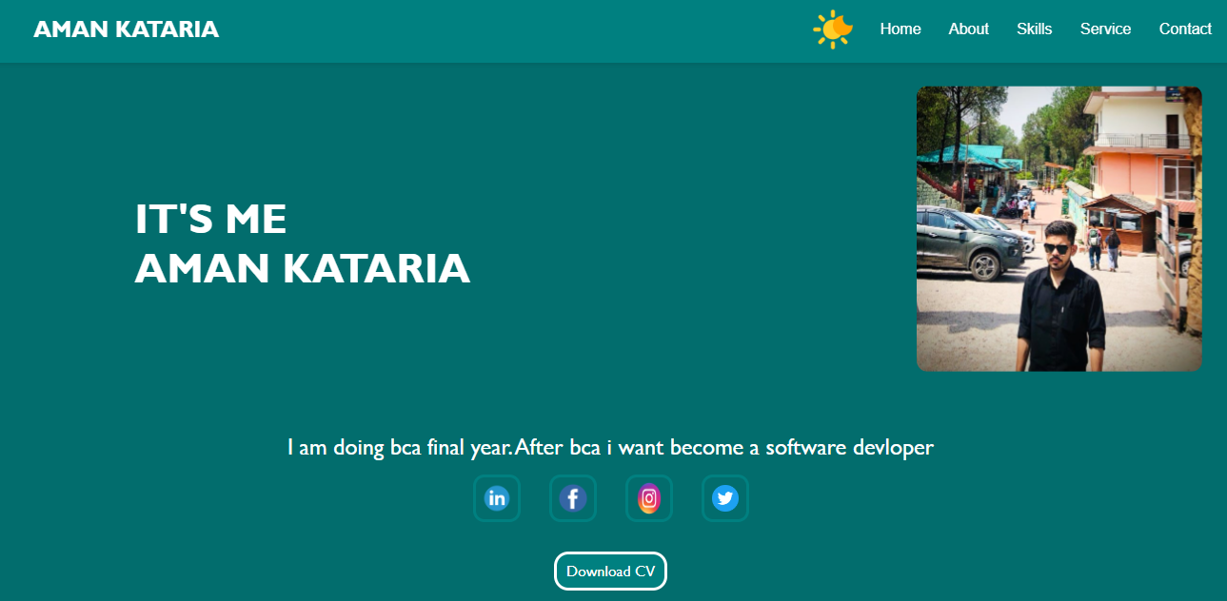

About section: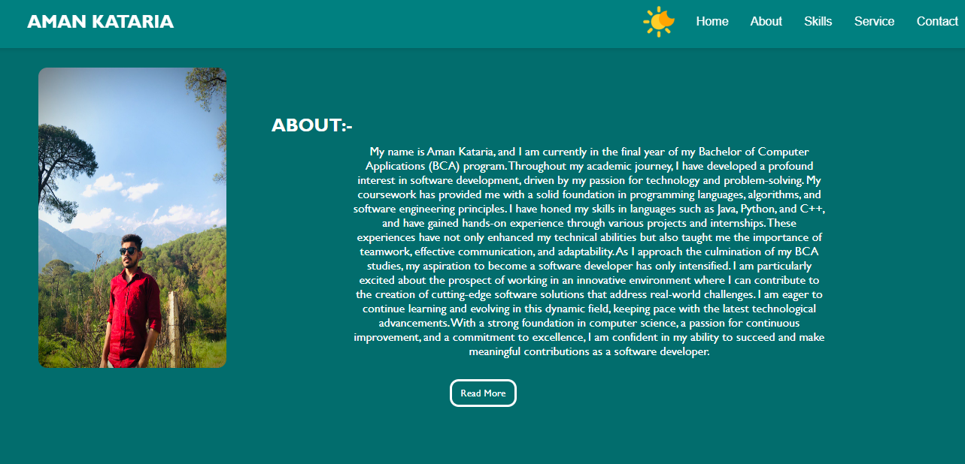

MY SKILLS SECTION:

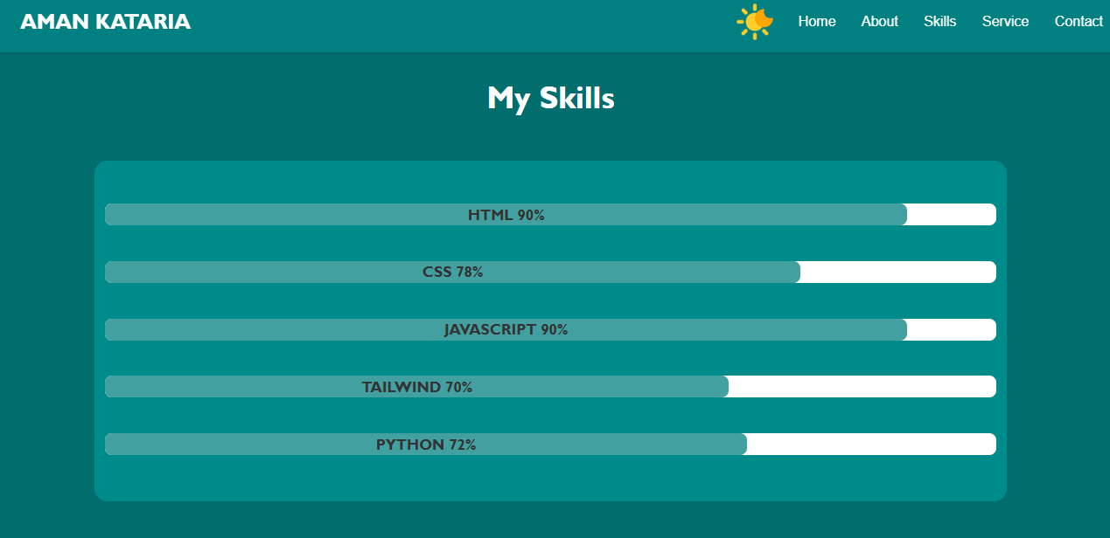

OUR SERVICE SECTION:

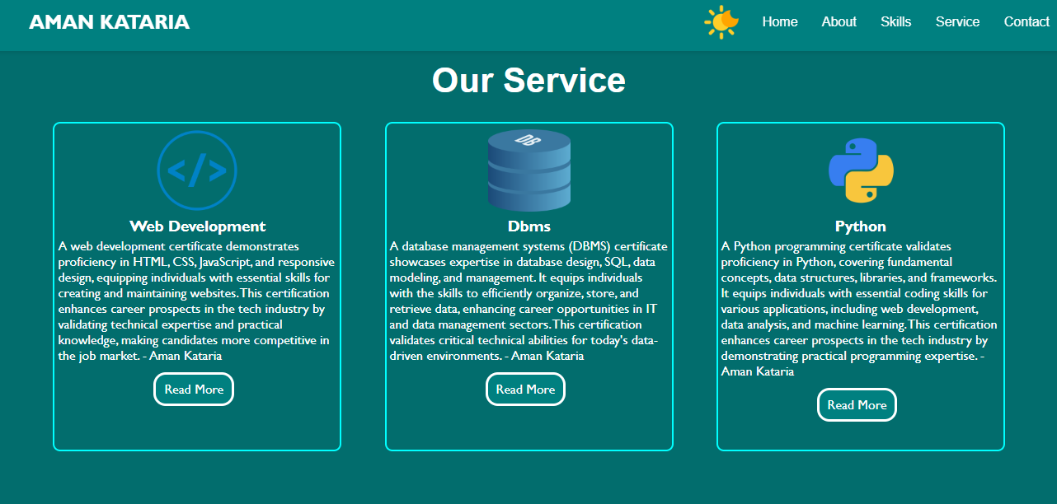

Projects section:

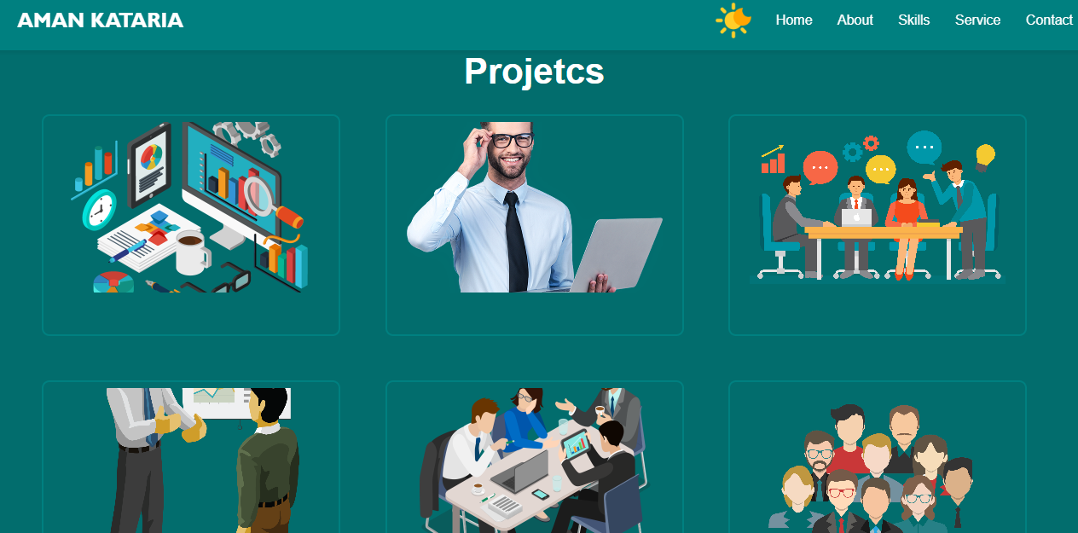

Contact section :

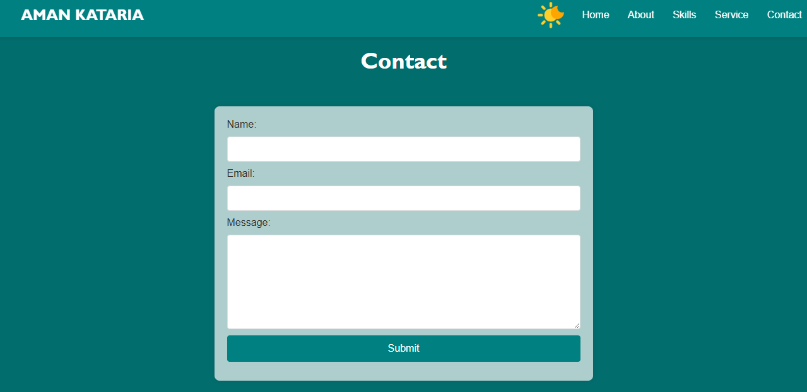

Footer call and email img section:

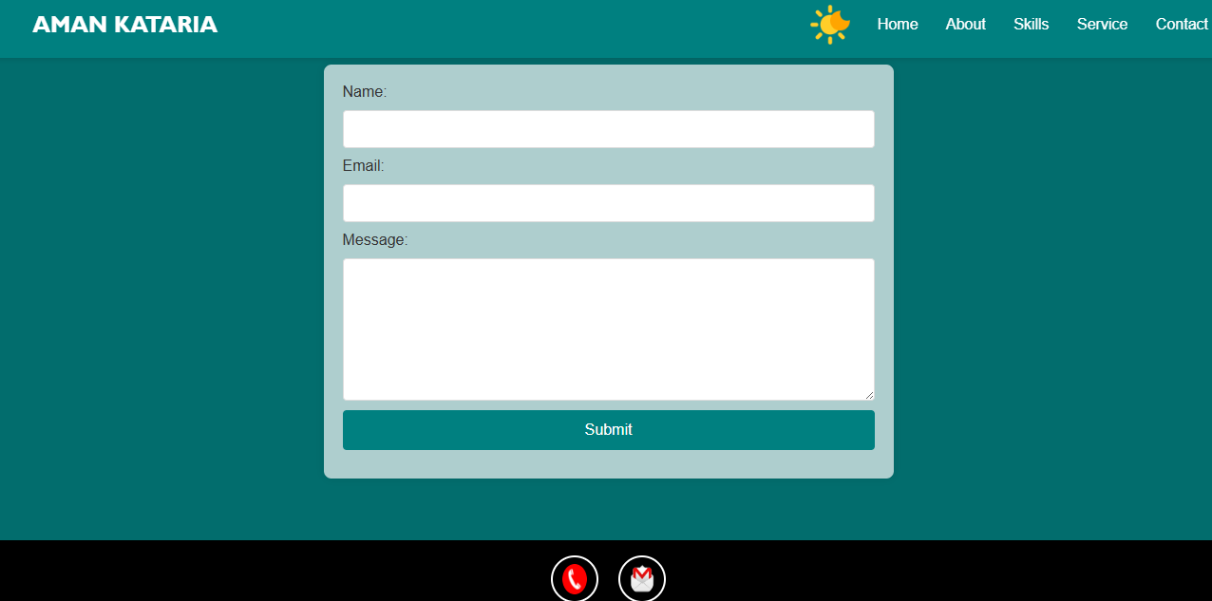

Responsive design :

1. Galaxy S8+ :  
   I have add screen recoding video with zip file.
2. Ipad mini :

I have add screen recoding video with zip file.